Warrior Aluminum and Steel Sideplates
INSTALLATION INSTRUCTIONS

All “SIDE PANELS” are designed to be placed over the existing metal surface. They fit between the fender wells with factory fenders and fender flares where applicable. X versions require the front edge to be trimmed to fit.

Warrior’s recommended installation procedure for all Sideplates utilizes drilled holes and pop-rivets. Other installations such as self-tapping screws and two sided tape are adequate but will not be covered in this installation guide.

You will need a pop-rivet tool, drill, and 3/16” drill bit to complete this installation. Below is a photo of a basic pop-rivet tool.

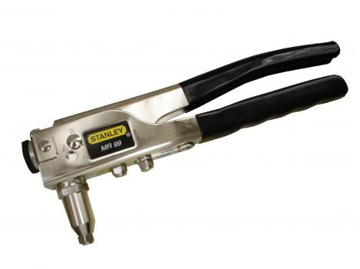

- Clean the rocker panel surface where the Sideplates will be installed. Ensure that any bare metal is primered or painted and that the surface is flat.
- Hold your Sideplates in place and choose spots to drill holes for mounting. We recommend mounting in all 4 corners, and then choose some spaces across the top and bottom edge to ensure that the plate doesn’t bow out anywhere. If you are covering rusted spots on the Jeep, do not try to pop rivet into the rusted areas.
- Remove the sideplate and drill the holes you’ve marked in the sideplate using a 3/16” drill bit.

- At this point, you may choose to use a silicone or RTV sealant around the edges of the sideplate, or perhaps a rubber gasket. Choosing to do so is at your discretion, and if you choose not to seal it, moisture can get between the plates and cause rust issues.
- Place your drilled sideplate back onto the vehicle, and align it to where you’d like it to be. Drill thru the first layer of the rocker panel one hole at a time, and install a pop rivet into each hole as you drill it. Once you’ve drilled and riveted each hole and you’re satisfied with the quantity and locations, you have completed the installation.
- Repeat the previous 5 steps for the other side of the vehicle.
- Installation is complete.

