Diamond Plate & Steel Tailgate Covers
INSTALLATION INSTRUCTIONS

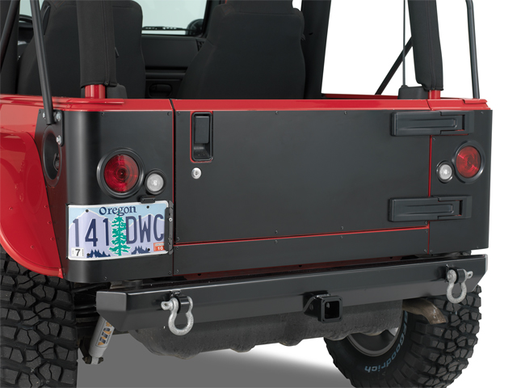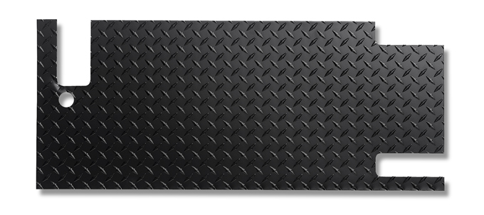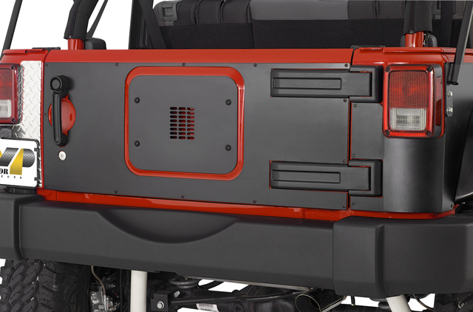

IMPORTANT: Warrior only recommends one method of installation. This method includes drilling holes and pop-riveting the tailgate cover into place, and will be the method covered in these instructions. Actual mounting hardware & method are at the discretion of the installer. Any gasket or sealants used are also at the same discretion. All covers are designed to overlay the existing factory tailgate with factory hinges and latches.

BEFORE INSTALLING: Ensure that your tailgate is clean, and free of bends.

- Newer model Wranglers may have plastic hinge covers. Remove these carefully.
- Primer/Paint any bare metal surfaces of the tailgate that you do not want to rust.
- Hold the tailgate cover in place, lining it up the way you’d like and designate areas to pop-rivet the cover into place. By recommendation, you should have 8 rivets in the cover, 4 across the top edge and 4 across the bottom edge evenly spaced. Mark these holes on the tailgate cover and drill holes at those marks into the tailgate cover. You can then carefully use the tailgate cover as a template to mark the same 8 holes in the tailgate itself. Drill bit size is 3/16”.
- You should now have 8 holes drilled in your cover, and your tailgate. At this time, it is recommended that you paint around the surface of the holes you drilled in the tailgate to seal them from rusting. A touch up paint kit from your dealer works well for this. Allow paint time to dry.
- At this time, if you choose to silicone seal around the holes you’ve drilled and edges of the cover, or if you’re using a gasket of some sort, now is the time to apply it.
- Place the tailgate cover over the tailgate and begin pop-riveting the tailgate into place. A simple handheld pop-rivet tool can be found at virtually any tool store.
- If you choose, re-install your plastic hinge covers. Getting the covers to fit again may require trimming to the outer edge to compensate for the thickness of the tailgate cover metal.
- This completes your installation. Warrior recommends our line of rear corners, back plates, and side plates to compliment your tailgate cover. For more information, visit www.warriorproducts.com

